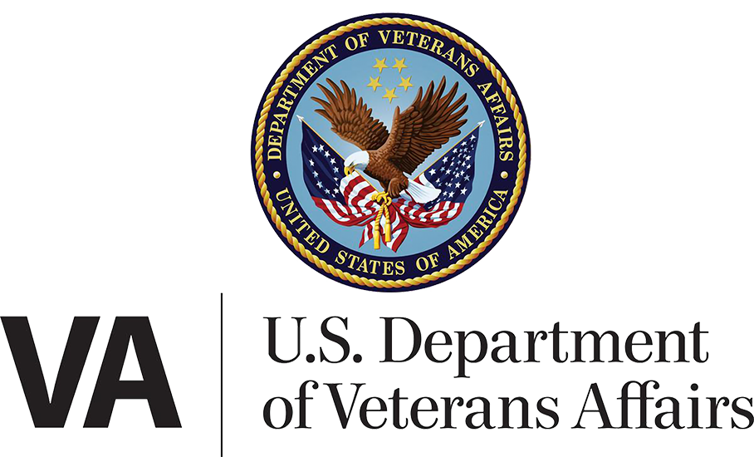

Department/CTO Heath Team

March 21, 2023 | MyHealtheVet on VA.gov Landing Page

Version 1.0

Revision History

| **Date** | **Version** | **Description** | **Author** |
| --- | --- | --- | --- |
| 03/09/2023 | 1 | Product Debut | Marci McGuire |

Table of Contents

1. Product Overview 4

2. User Access 4

3. Navigation 4

4. MyHealtheVet on VA.gov landing page screen shot 5

## 1. Product Overview

The MyHealtheVet on VA.gov landing page will serve as a new front door to VA health-related applications currently hosted on the MyHealtheVet website. These applications are in the process of being migrated one by one to VA.gov, and should be fully integrated by late October 2024. This is a very basic overview for the initial landing page rollout, and will be updated and expanded as more features are added.

## 2. User Access

During the initial rollout currently scheduled to begin the week of March 21, 2023, users who log into VA.gov will see a new “MyHealtheVet” link in the header.

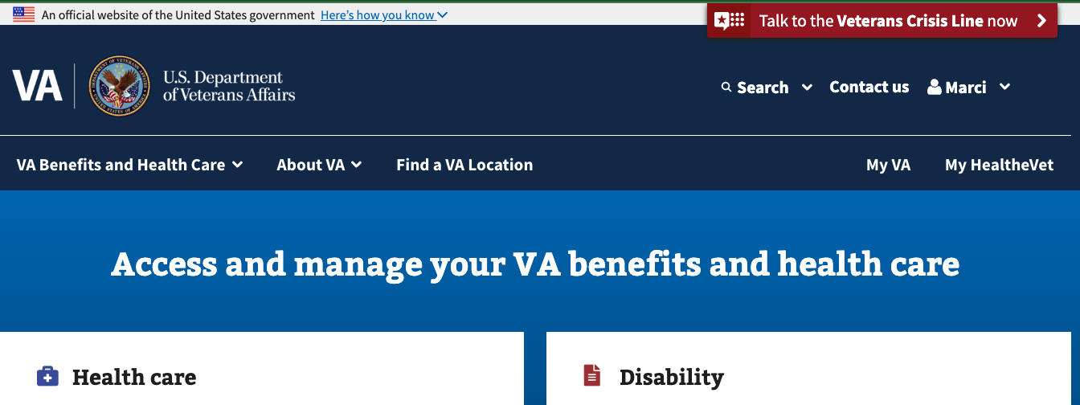

For the majority (95% of daily users initially), this link will go to the existing MyHealtheVet web site. It will send them to the new landing page if they meet all of the following criteria:

* Logged into VA.gov with using ID.me or Login.gov
* Have never received health care at a VA Medical Center where Cerner has been rolled out
* Are in the 5% of daily users for whom a feature toggle is enabled

## 3. Navigation

The landing page is a single static page containing links to content and applications that already exists. Once logged in to VA.gov, users should not have to log in a second time to access any of the landing page links. A screen shot of the landing page (Figure 1) is shown on page 5.

## 4. MyHealtheVet on VA.gov landing page screen shot

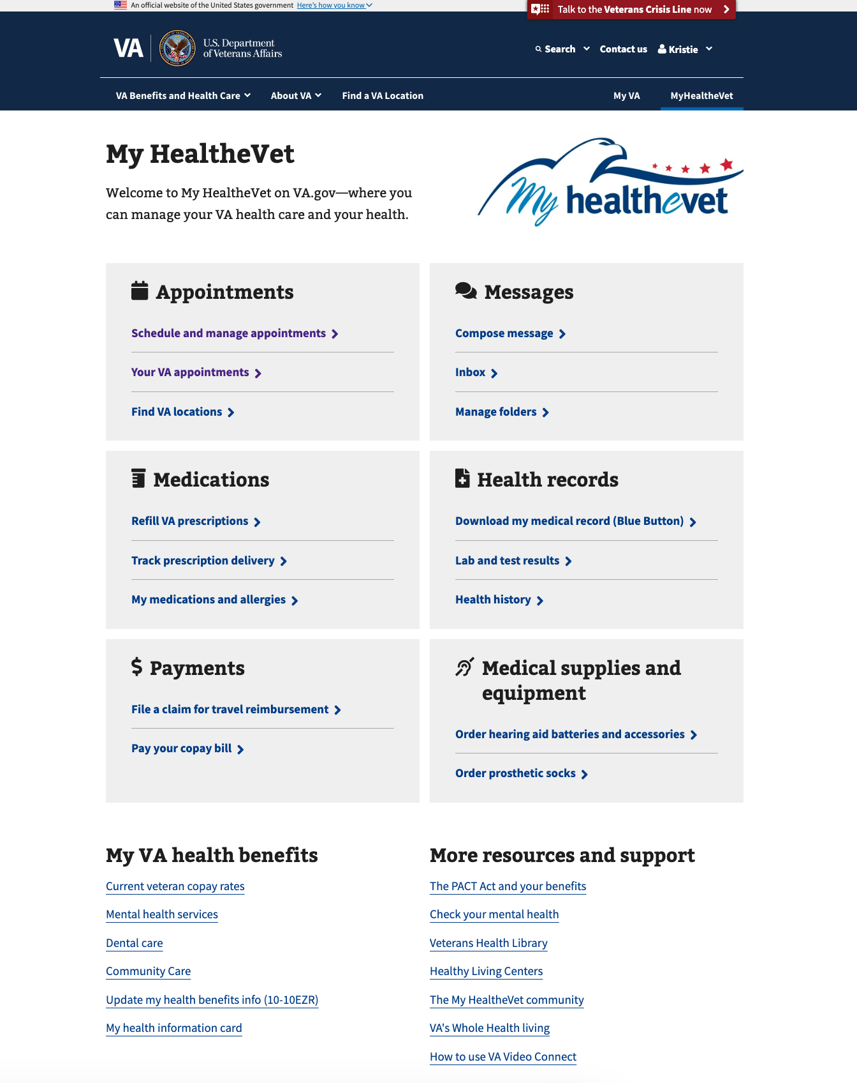

*Figure 1. Image of new MyHealtheVet on VA.gov landing page*